Combined Victorian Society Testimony for May 2, 2023
Public Meeting Item, Not to Be Read:
LPC-22-05759 329 Greenwich Street - Tribeca West Historic District – Manhattan
Public meeting, May 2, 2023
The Victorian Society continues its objection to this sidewalk replacement proposal, heard last October 25. The surviving historic granite sidewalk slabs with vault lights warrant more consideration than full scale demolition. Distinctive 19th century paving and bullet glass set in cast-iron armatures have disappeared from too many historic warehouses.
The current submission appears little different from the last, and the engineer’s letter tells us what we already knew—that the vault is in poor condition. It gives no reason that in-kind replacement of visible materials isn’t possible. We note that the vault is to be reconstructed regardless, with new steel and concrete. The issue is the nature of the materials and details that are visible to the public at street level.
Demolishing this historic stone sidewalk, and the vault lights, only to replace them with modern concrete, would diminish the sense of place found in the Tribeca West Historic District. Even the new curb is proposed to be concrete, when the LPC and DOT standard for 30 years for replacement curbs in this and similar districts has been granite.
The applicant should research, with the help of LPC staff, ways to retain and incorporate all sound granite slabs into the new sidewalk system. Circle Redmont makes new vault light sections which would replicate the historic condition. Granite is readily available. With proper detailing and adequate waterproofing, the new sidewalk can be durable, distinctive and respectful of this 1887 warehouse and the neighborhood.

Approximate time: 11:00; join Zoom by: 10:00.
LPC-23-08020 -- 120 Broadway - Equitable Building - Individual Landmark, Manhattan
Good morning commissioners, ___________ for the Victorian Society New York. Founded in New York City in 1966, the Victorian Society in America is dedicated to fostering the appreciation and preservation of our 19th and early 20th century heritage. The NY chapter promotes preservation of our historic districts, individual and scenic landmarks, interiors and civic art.
We found the presentation material for this application so lacking in clarity that it was difficult to prepare testimony. The existing and proposed elevations of the storefront bay in question are too small and lacking in detail, making it difficult to understand the proposed design. There is no detailed view that would show us what the historic storefronts were like, to help guide the new design, so we have provided below photographs from 1915 and 1930. As would be expected, the ground floor once had a design commensurate with the rest of the building.
We know that the Commission can’t require restoration of historic features missing at the time of designation. Nonetheless, we don’t understand how such a pedestrian storefront design, using anodized aluminum, can be an appropriate standard for a building of this consequence.
The existing step and ramp and the proposed replacement ramp are referred to variously as “granite,” “granite tile,” and “granite finish.” Which is it? At least part of the existing step looks historic. An original step here would have been solid granite, in one piece or possibly two or three sections. We don’t think it would be inappropriate to replace the existing material with a single ramp of granite. But it would have to be a single large slab of stone or perhaps two or three. A different material with a “granite finish” or granite tiles, which implies small pavers on concrete, would be inappropriate. No details of this new ramp are provided.
Finally, we think the ramp may not be ADA compliant, as the door swing interferes with the required 5-foot level landing. This should be verified to ensure that the applicant doesn’t have to return with a revision.
We suggest that a decision on this application await resubmission of an improved and properly documented proposal.

See photographs on the following two pages.
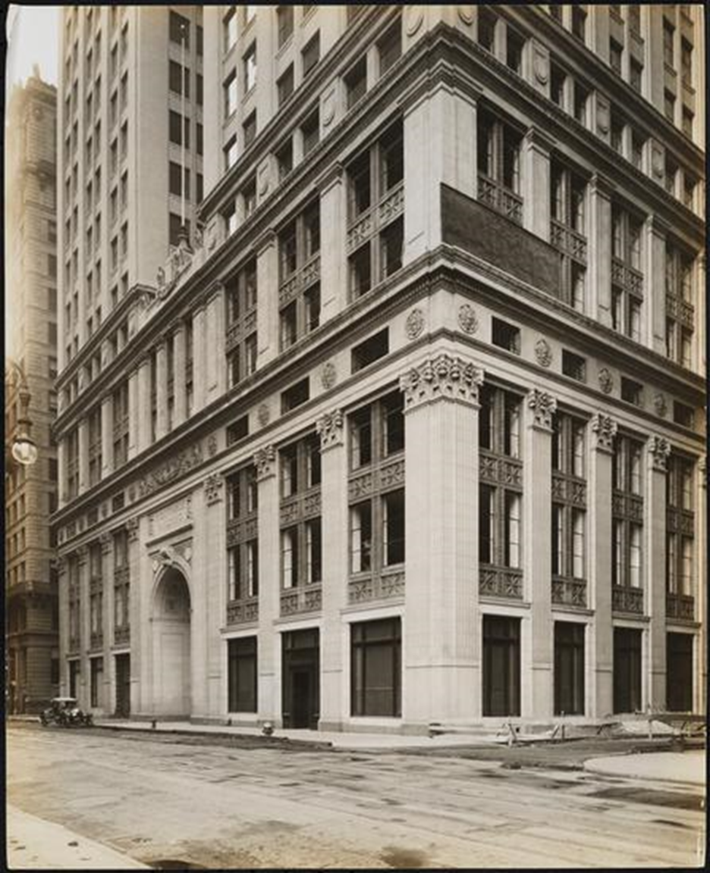
Ca. 1915, Museum of the City of New York

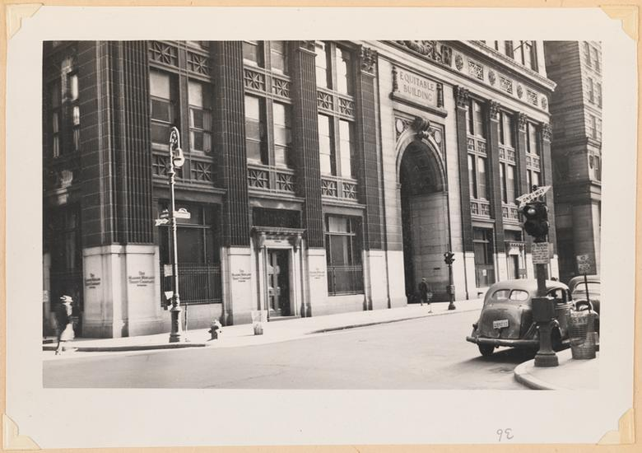
Ca. 1930, Museum of the City of New York

Approximate time: 1:00; join Zoom by: 12:45.
LPC-23-07180 – 1260 Broadway - Hotel Martinique - Individual Landmark - Manhattan
Good afternoon commissioners, ______________ for the Victorian Society New York.
The applicant for 1260 Broadway is proposing a number of significant changes to this long-neglected landmark. The Victorian Society is happy to support work which addresses decades of neglect, and we are confident that the building’s overall appearance will be vastly improved. However, as is often the case where many individual elements are being addressed, we believe some need additional refinement.
We fully support the proposed indirect lighting package, the modifications to the vertical signs, and the storefront signage. The painted wood and glass doors on the 33rd Street side of the building, shown on drawing 27, are a good match for historic doors found on buildings of this age and type. The new louvers the applicant is proposing to install behind muntin grids in several locations, finished to match the grids, will be unobtrusive.
Although the proposed marquee is shorter than the historic marquee, we believe it’s large enough to balance the mass of the building and will draw attention in all the right ways. However, we urge the applicant to restore the globe lights at each corner of the marquee, as seen in both the historic drawing and the historic photograph on board 16. And while we accept the cable supports above the marquee, we also urge the installation of a pair of the historic bracket supports set under the marquee, which are also seen in the historic photos.
We support the installation of the ground floor windows with circular heads and muntin grids. However, there aren’t any dimensioned drawings for the grids. In the elevation on Board 16, they look too wide and flat. A dimensioned section of the grids should be provided.
On Board 16 there’s also a drawing of the round headed windows showing a new “EXISTING OR REPLICATED HISTORIC DECORATIVE BAND.” This raises two questions. First, it looks like the design of the bands is taken from historic square headed windows, when there are historic round headed windows which have similar detailing: They should use the detailing from the latter. And second, the material and finish of these bands isn’t shown.
Board 21 shows new decorative GFRC columns set on stone bases on the Broadway façade. Since there isn’t an actual sample we could see and touch, we don’t know what the final finish will be like. We urge special care in approving samples for these columns set just above the sidewalk, which will be easy for pedestrians to touch and knock with an umbrella. The material needs to be thick enough to “sound” like stone.
Finally, we were disappointed that the applicant didn’t provide drawings showing the full extent of terra cotta and stone repairs on the lower two floors.
Thank you, commissioners.

Approximate time: 1:45; join Zoom by: 1:00.
LPC-23-09159 – 200 Convent Avenue - City College, City University of New York (CUNY), North Campus - Individual Landmark, Manhattan
Good afternoon commissioners, _____________ for the Victorian Society New York.
We are happy to support the proposed new entrance to Wingate Hall. The replacement of street-level windows with a sensitively designed door is a reasonable and respectful way to update George Post’s design for modern needs. Using the historic building’s vocabulary and details for the new archway echoes the arched windows on the top floor and preserves the character and unity of Post’s original design. We’re particularly happy to see the inclusion of the beautiful lampposts and feel this alteration will be a welcome addition to the building.
We also commend the approach of infilling the openings in the tower to create blind windows where the elevator shaft will be, a traditional approach to preserving the symmetry of a facade.

